**Table of Contents**

1. **Introduction**
2. **Scope**
3. **Key Features**
4. **Functionalities**
5. **System Architecture**
6. **Implementation Plan**
7. **Use of Software for Targeted Audiences**
8. **Problems Without This Software**
9. **Snapshots**
10. **Conclusion**

**1. Introduction**

The MIT Store Order Management system is designed to streamline and automate the process of managing orders within the MIT Store. This report outlines the scope, key features, functionalities, overall architecture, targeted audiences for the system, and the potential problems faced without such a software solution.

The MIT Store, known for its diverse range of products and services, has faced several challenges in managing its order processing, inventory, and customer interactions. Traditional manual processes and outdated systems have led to inefficiencies, errors, and delays that impact overall store performance and customer satisfaction. Recognizing these challenges, the MIT Store initiated the development of an advanced Order Management system designed to automate and optimize these key areas.

**1.2 Objectives**

The primary objectives of the MIT Store Order Management system are:

* **Streamline Order Processing:** Automate the order creation, tracking, and fulfillment processes to reduce manual errors and processing times. This helps ensure that orders are handled promptly and accurately.
* **Enhance Inventory Management:** Provide real-time updates on inventory levels, automate stock adjust
* tments, and generate alerts for low-stock items. This aids in maintaining optimal inventory levels and prevents stockouts or overstocking.
* **Improve Customer Service:** Offer customers real-time order tracking and status updates, manage customer inquiries efficiently, and personalize communication based on purchase history. This aims to enhance the overall shopping experience and increase customer satisfaction.
* **Generate Valuable Insights:** Deliver comprehensive reporting and analytics on sales, inventory, and customer behavior. These insights assist store managers in making informed decisions and strategizing for future growth

**1.3 Scope of the Report**

This report provides a comprehensive overview of the MIT Store Order Management system, including:

* **System Overview:** An outline of the system's features, functionalities, and architecture.
* **Implementation Plan:** A detailed description of the phases involved in developing and deploying the system.
* **Targeted Audiences:** Identification of the key stakeholders and how the system addresses their needs.
* **Challenges Without the System:** An analysis of the problems and inefficiencies the store would face without the Order Management software.
* **Conclusion:** A summary of the benefits and impact of the system on the MIT Store’s operations.

**1.4 Importance of the System**

The implementation of the MIT Store Order Management system is a strategic move to enhance operational efficiency, reduce errors, and improve customer satisfaction. By leveraging advanced technologies and automation, the system addresses the limitations of manual processes and outdated methods, positioning the MIT Store to better meet the demands of modern retail operations

**2. Scope**

The Order Management system is intended to handle all aspects of order processing, from order creation and tracking to inventory management and customer service. It aims to improve efficiency, reduce errors, and enhance the overall customer experience.

**2.1 Objectives**

The primary objectives of the Order Management system are:

* **Automate Order Processing:** Simplify and accelerate the order creation, approval, and fulfillment processes to reduce manual intervention and errors.
* **Enhance Inventory Management:** Implement real-time tracking and automated adjustments of inventory levels to ensure accurate stock management and timely replenishment.
* **Improve Customer Interaction:** Offer advanced features for customer engagement, including real-time order tracking, notifications, and personalized communications.
* **Provide Analytical Insights:** Generate detailed reports and analytics on sales, inventory, and customer behavior to support data-driven decision-making and strategic planning.

**2.2 System Components**

The Order Management system covers several key components:

**Order Creation and Processing:**

* + **Order Entry:** Allows for the easy and accurate entry of new orders, capturing essential details such as product information, quantities, and customer data.
  + **Order Tracking:** Provides real-time status updates on order progress, including order confirmation, processing, shipping, and delivery.
  + **Payment Integration:** Facilitates secure payment processing through integration with various payment gateways.
* **Inventory Management:**
  + **Stock Tracking:** Monitors inventory levels in real-time, updating stock counts automatically as orders are placed and fulfilled.
  + **Stock Alerts:** Sends notifications for low-stock items and triggers automated reorder processes to maintain optimal inventory levels.
  + **Inventory Reports:** Generates detailed reports on stock levels, turnover rates, and inventory valuation.
* **Customer Management:**
  + **Customer Profiles:** Maintains comprehensive profiles for each customer, including purchase history, preferences, and contact details.
  + **Order History:** Tracks and displays a complete history of past orders for each customer, facilitating better service and support.
  + **Personalized Communication:** Enables targeted messaging and promotions based on customer behavior and preferences.

**Reporting and Analytics:**

* + **Sales Reports:** Provides insights into sales performance, including daily, weekly, and monthly sales summaries.
  + **Inventory Reports:** Offers detailed views of inventory status, including stock levels, turnover rates, and valuation.
  + **Customer Analytics:** Analyzes customer behavior, including purchasing patterns and engagement metrics, to identify trends and opportunities.

**2.3 Implementation Scope**

The implementation scope includes the following phases:

* **Requirement Gathering:** Collect and document detailed requirements from stakeholders to ensure the system meets all operational needs.
* **System Design:** Create architectural designs and prototypes based on gathered requirements, including frontend and backend components.
* **Development:** Develop the system’s features and functionalities, integrating necessary tools and technologies.
* **Testing:** Conduct comprehensive testing, including unit testing, integration testing, and user acceptance testing, to ensure system reliability and performance.
* **Deployment:** Deploy the system in a live environment, ensuring all components are operational and accessible to users.
* **Training and Support:** Provide training for users and ongoing support to address any issues and ensure smooth system operation.

**2.4 Limitations**

While the Order Management system addresses many needs, certain limitations should be noted:

* **Integration with Legacy Systems:** Challenges may arise when integrating with existing legacy systems or third-party tools not fully compatible with the new system.
* **Initial Setup and Training:** The initial setup and user training require time and resources to ensure a smooth transition and effective system use.
* **Ongoing Maintenance:** Regular maintenance and updates are necessary to address bugs, security vulnerabilities, and evolving business requirements.

**3. Key Features**

**1. Order Creation and Processing**

* Automated order entry
* Real-time order tracking
* Integration with payment gateways

**2. Inventory Management**

* Real-time inventory updates
* Automated stock level monitoring
* Low-stock alerts

**3. Customer Management**

* Customer profile management
* Order history tracking
* Personalized communication

**4. Reporting and Analytics**

* Sales and order reports
* Inventory reports
* Customer behavior analytics

**4. Functionalities**

**Order Creation**

1. Users can create orders through a user-friendly interface.
2. Orders are automatically logged into the system and assigned a unique ID.

**Order Tracking**

1. Real-time updates on order status.
2. Notifications sent to customers at each stage of order processing.

**Inventory Management**

1. Automatic adjustment of inventory levels upon order placement.
2. Detailed inventory records and reports.

**Customer Service**

1. Easy access to customer information.
2. Ability to track and manage customer inquiries and complaints.

**5. System Architecture**

**Frontend**

Built using modern web technologies (HTML, CSS, JavaScript).

Responsive design to ensure compatibility with various devices.

**Backend**

Developed using a robust framework (Django).

Restful APIs for communication between frontend and backend.

**Database**

Relational database (e.g., MySQL, PostgreSQL) for storing order and customer data.

Ensures data integrity and security.

**6. Implementation Plan**

* **Phase 1: Requirement Analysis**

Gather detailed requirements from stakeholders.

Define project scope and objectives.

* **Phase 2: Design**

Design system architecture.

Create wireframes and prototypes.

* **Phase 3: Development**

Develop frontend and backend components.

* **Phase 4: Testing**

Conduct unit and integration testing.

Perform user acceptance testing.

* **Phase 5: Deployment**

Deploy the system to a live environment.

Monitor performance and address any issues.

**7. Use of Software for Targeted Audiences**

The MIT Store Order Management system is designed to cater to various stakeholders within and related to the MIT Store. The key targeted audiences include:

* **Store Managers**

1. Need to efficiently manage orders, inventory, and overall store operations.
2. Require detailed reports and analytics to make informed business decisions.

* **Sales Staff**

1. Benefit from a streamlined order entry and tracking process.
2. Can provide better customer service with easy access to customer profiles and order histories.

* **Customers**

1. Experience a smoother shopping experience with real-time order tracking and notifications.
2. Receive personalized communication based on their purchase history.

* **Inventory Managers**

1. Can monitor stock levels in real-time and receive alerts for low-stock items.
2. Ensure that the store is adequately stocked without overstocking, optimizing inventory costs.

* **IT and Support Staff**

1. Responsible for maintaining the system, ensuring it runs smoothly, and addressing any technical issues.
2. Require access to backend functionalities and system health reports.

**8. Problems Without using this Software**

Without the Order Management software, the MIT Store would face several significant challenges:

* **Manual Order Processing**

1. Higher risk of human errors in order entry and processing.
2. Increased time and labor required to manually handle orders, leading to inefficiencies.

* **Inventory Management Issues**

1. Difficulty in tracking inventory levels accurately, resulting in overstocking or stockouts.
2. Lack of real-time updates could lead to delayed replenishment of stock.

* **Customer Service Challenges**

1. Inability to provide real-time order status updates to customers.
2. Difficulty in managing customer inquiries and complaints effectively.

* **Lack of Reporting and Analytics**

1. Limited insights into sales trends, inventory levels, and customer behavior.
2. Challenges in making data-driven business decisions without accurate and timely reports.

* **Increased Operational Costs**

1. Higher operational costs due to manual processes and inefficiencies.
2. Potential loss of sales and customer dissatisfaction due to delayed or incorrect order processing.

**9.Snapshots**

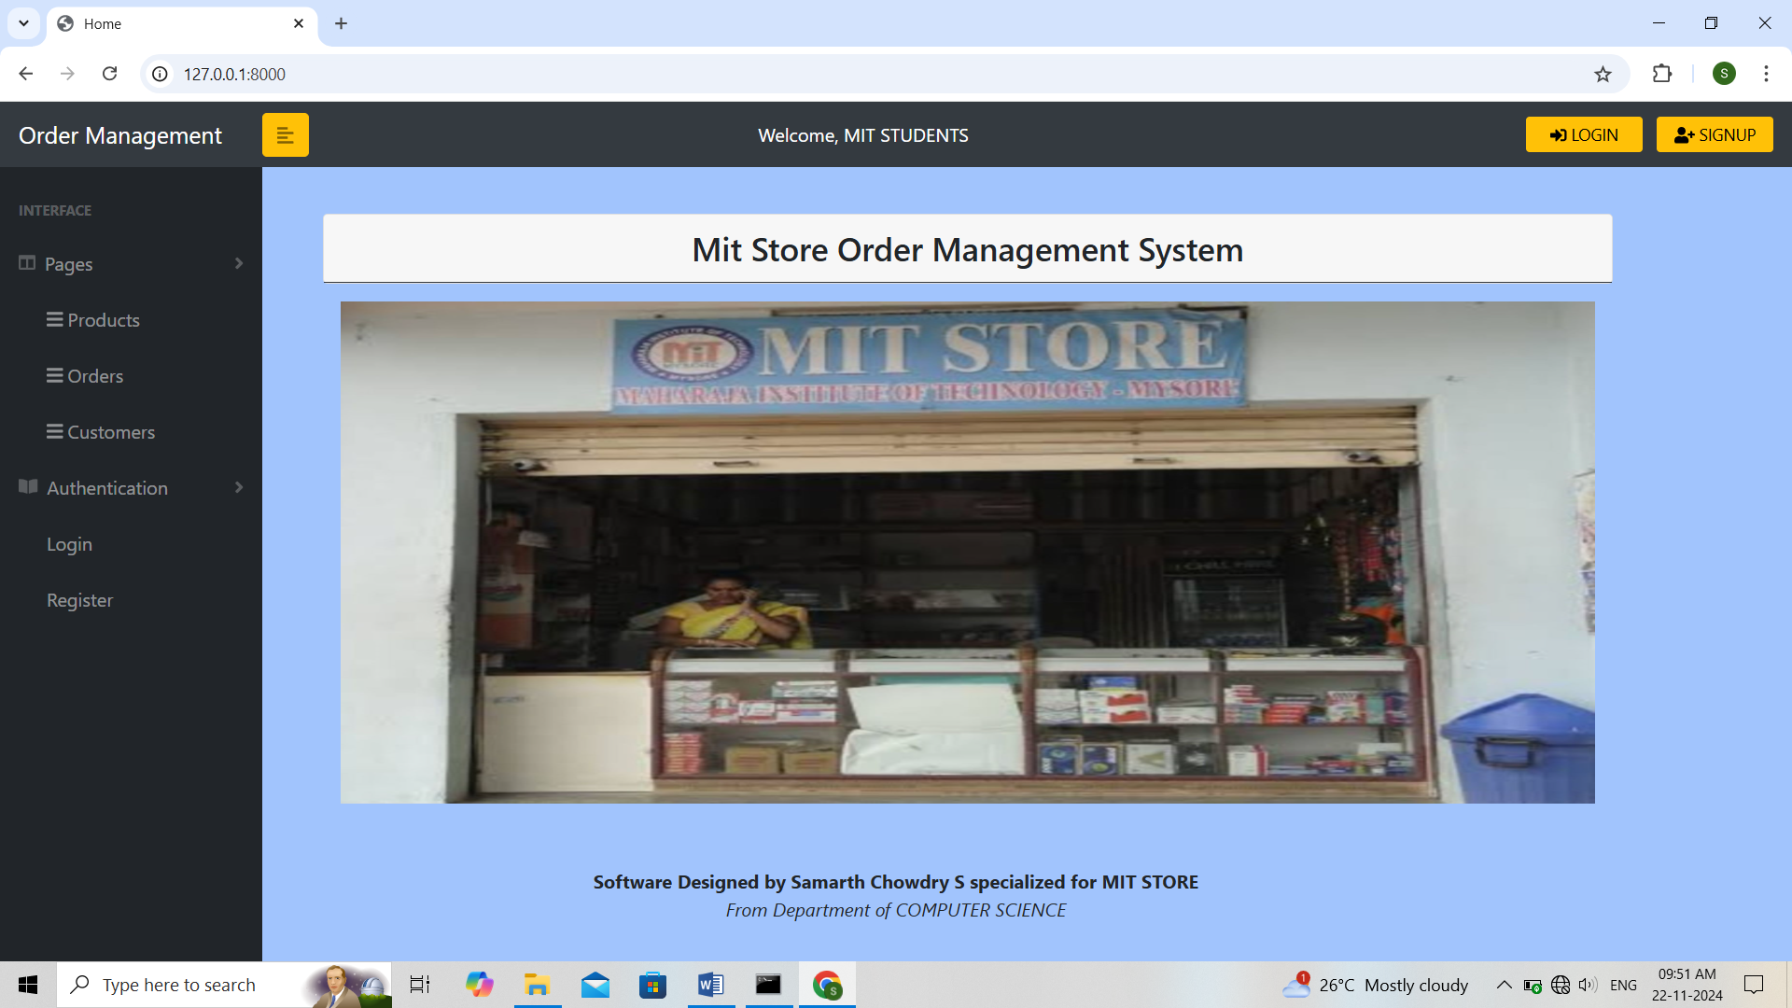

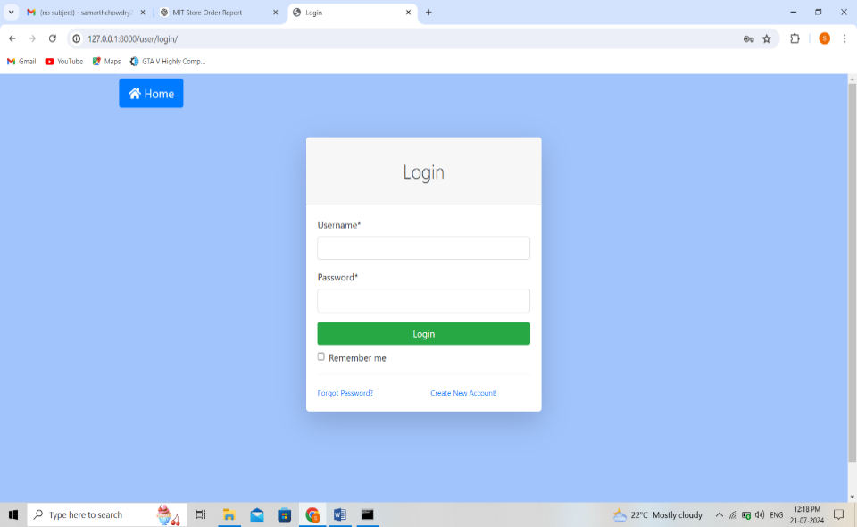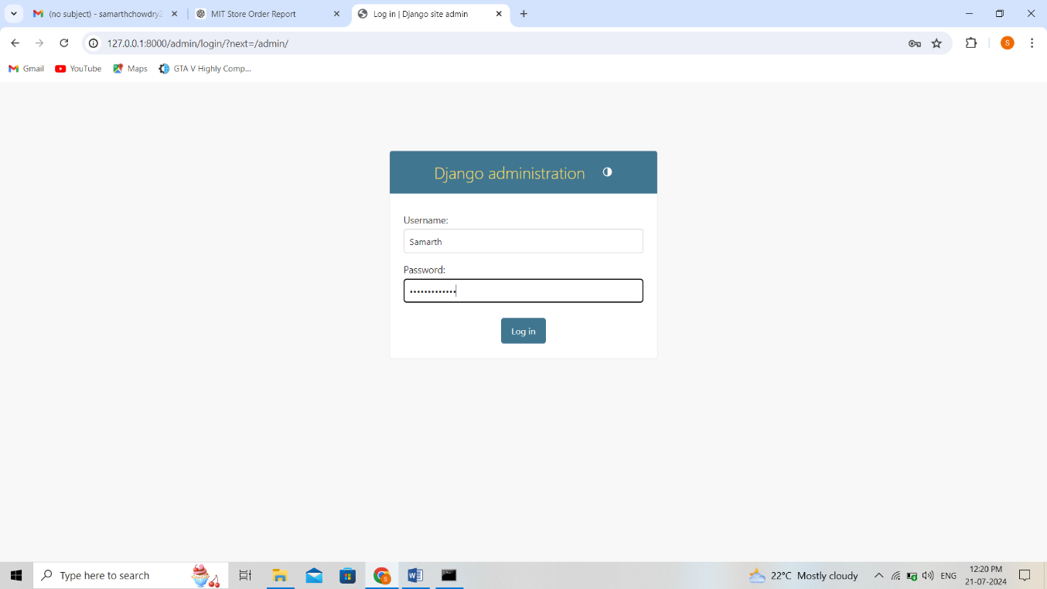

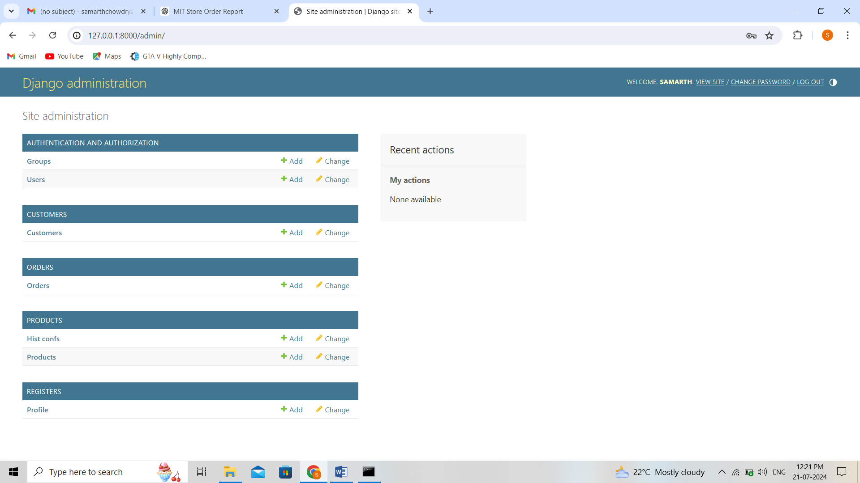

**10. Conclusion**

The MIT Store Order Management system is a comprehensive solution designed to improve order processing efficiency, enhance customer satisfaction, and provide valuable insights through detailed reporting and analytics. With its robust architecture and user-friendly interface, the system is poised to significantly benefit the operations of the MIT Store and its various stakeholders, addressing many of the challenges that would arise in the absence of such a software solution.